AXI + UART Integration 2
1. Title 2
2. Objective 2
3. Theory (Multi-Level) 2
3.1 Beginner — Simple Intuition 2
3.2 Intermediate — Engineering View 2
3.3 Advanced — Signal/Architecture Level 3
4. Architecture / Concept 4
uart_axi Internal Block Diagram 4
AXI-UART Data Flow (Full End-to-End) 5
5. Implementation 5
Files in This Module 5
Key Code Paths in rtl/uart_axi.v 6
6. Lab / Hands-on Section 6
Step 1: Run AXI-UART Integration Testbench 6
Expected Terminal Output 6
Step 2: View AXI-UART Waveform 7
7. Waveform / Verification Insight 8
AXI Write → UART TX Timeline 8
Backpressure Observation 8
RX Path Timeline 8
8. Common Issues & Debug Tips 8
Debug: Trace buf_valid Signal 9
9. Summary 9

AXI + UART Integration
Course: PicoRV32 SoC with AXI-Lite & UART Integration
Lab Commands: make axi_uart → make wave

1. Title
AXI + UART Integration — UART Peripheral as an AXI-Lite Slave

2. Objective
By the end of this module, learners will be able to:
- Explain how a UART peripheral is exposed as an AXI-Lite slave
- Map the uart_axi module’s internal registers to AXI addresses
- Trace a complete AXI write → UART TX byte-serialization path
- Trace a complete UART RX → AXI read path
- Run the make axi_uart testbench and observe data flow through the AXI-UART pipeline

3. Theory (Multi-Level)

3.1 Beginner — Simple Intuition
Imagine you want to use a UART peripheral in an AXI-based SoC. The UART speaks “serial bits”, the AXI bus speaks “parallel register reads/writes”. We need an adapter:
- You write to AXI address 0x10000000 → the adapter stores the byte and triggers UART TX
- UART receives a byte → the adapter stores it → you read AXI address 0x10000004 to get it
- You read AXI address 0x10000008 → the adapter tells you if new data is waiting
The uart_axi.v module is this adapter. Externally it looks like a simple register bank to the AXI bus; internally it drives the uart_tx.v and reads from uart_rx.v.

3.2 Intermediate — Engineering View
uart_axi.v Register Map:
AXI Address | Access | bit[8] | bits[7:0] | Description
0x10000000 | Write | — | TX data | Write byte to transmit
0x10000004 | Read | rx_valid | rx_data | Read received byte (clears rx_buf_valid)
0x10000008 | Read | — | {rx_valid, 1'b0} | Status: bit[1]=rx_buf_valid
Write path (AXI → UART TX):
AXI master write to 0x1000_0000
→ uart_axi captures (aw_got=1, w_got=1)
→ w_byte ← wdata[7:0] (based on wstrb)
→ buf_data ← w_byte; buf_valid ← 1
→ uart_tx gets: data=buf_data, valid=1
→ 8N1 serial bitstream on tx_out pin
→ B response sent back: OKAY (2'b00)
Read path (UART RX → AXI):
uart_rx detects start bit on uart_rx pin
→ uart_rx shifts in 8 bits
→ data_valid pulse → rx_buf_data ← received byte; rx_buf_valid ← 1
AXI master read from 0x1000_0004
→ uart_axi returns {23'b0, rx_buf_valid, rx_buf_data}
→ rx_buf_valid ← 0 (cleared on data register read)

3.3 Advanced — Signal/Architecture Level
Write backpressure mechanism (ASIC-clean, from rtl/uart_axi.v):
// Ready assertions — held LOW when buffer is full
assign s_axi_awready = !aw_got && !buf_valid;
assign s_axi_wready = !w_got && !buf_valid;
This ensures that if the 1-byte TX buffer is full (buf_valid=1), the AXI master is stalled at the write data channel — AWREADY and WREADY go low, forcing the CPU bridge to wait. This prevents silent byte drops.
TX buffer state machine:
Reset: buf_valid=0, buf_data=0
If tx_ready && buf_valid: → tx_data←buf_data, tx_valid←1, buf_valid←0
If aw_got && w_got && !b_vld && !buf_valid: → buf_data←w_byte, buf_valid←1
(These two conditions interleave: UART drains buffer )
(as fast as possible, AXI refills when buffer is empty )
WSTRB byte selection:
if (s_axi_wstrb[0]) w_byte <= s_axi_wdata[ 7: 0]; // byte 0
else if (s_axi_wstrb[1]) w_byte <= s_axi_wdata[15: 8]; // byte 1
else if (s_axi_wstrb[2]) w_byte <= s_axi_wdata[23:16]; // byte 2
else w_byte <= s_axi_wdata[31:24]; // byte 3
This allows 8-bit firmware stores (SB instruction, wstrb=4’h1) to correctly target the lower byte of the 32-bit AXI data word.
Module parameters:
module uart_axi #(
parameter CLK_FREQ = 50_000_000, // System clock
parameter BAUD_RATE = 115_200 // Serial baud rate
)
// CLKS_PER_BIT = 50_000_000 / 115_200 = 434 cycles per bit

4. Architecture / Concept

uart_axi Internal Block Diagram
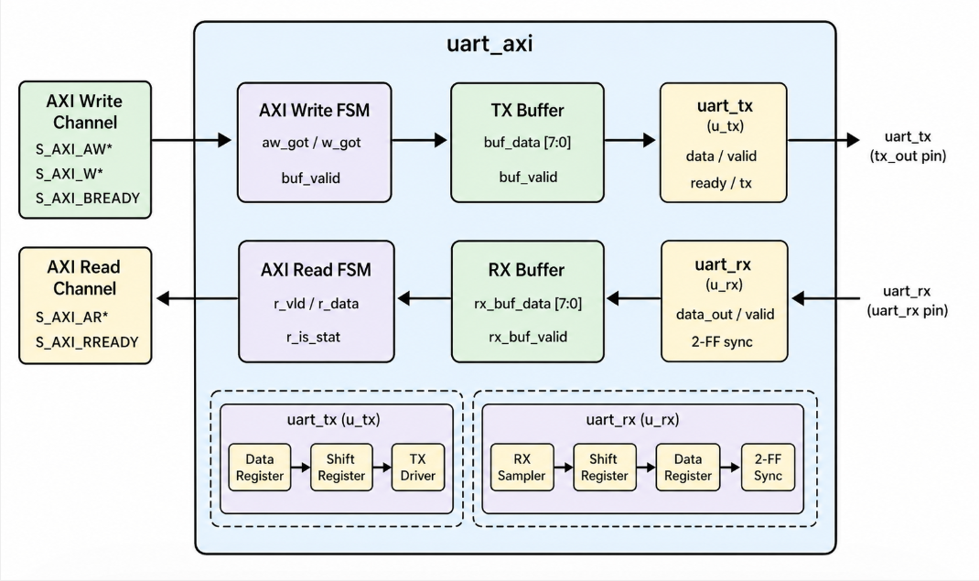

AXI-UART Data Flow (Full End-to-End)
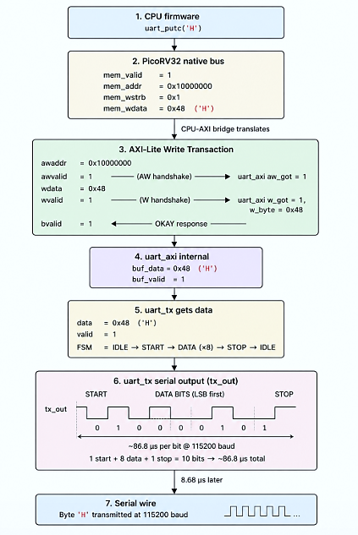

5. Implementation

Files in This Module
File | Role
rtl/uart_axi.v | UART peripheral as AXI-Lite slave — TX buffer + RX buffer + AXI controller
rtl/uart_tx.v | Instantiated inside uart_axi as u_tx
rtl/uart_rx.v | Instantiated inside uart_axi as u_rx
tb/tb_axi_lite.v | Testbench: AXI master + uart_axi DUT + UART serial monitor
tb/tb_axi_lite_master.v | Reusable AXI master task module

Key Code Paths in rtl/uart_axi.v
Write channel ready conditions (lines 172–173):
assign s_axi_awready = !aw_got && !buf_valid;
assign s_axi_wready = !w_got && !buf_valid;
RX read data format (lines 237–241):
if (s_axi_araddr[3:0] == 4'h8)
r_data <= {30'b0, rx_buf_valid, 1'b0}; // Status register
else
r_data <= {23'b0, rx_buf_valid, rx_buf_data}; // Data register: [8]=valid, [7:0]=data
Port naming note: The TX output is named tx_out (not uart_tx) to avoid Yosys scope-resolution collision with the submodule type name uart_tx. This is a real ASIC synthesis concern documented in the code:
output tx_out, // renamed: avoids collision with submodule type `uart_tx`

6. Lab / Hands-on Section

Step 1: Run AXI-UART Integration Testbench
cd /home/deep/nielit/projects/tested_projects/picorv32_soc
make axi_uart
This: 1. Cleans obj_axilite/ 2. Compiles: uart_tx.v + uart_rx.v + uart_axi.v + tb_axi_lite_master.v + tb_axi_lite.v 3. Runs ./obj_axilite/sim_axilite → produces tb_axi_lite.vcd 4. Opens GTKWave

Expected Terminal Output
--------------------------------------------------
AXI-UART Testbench Started
--------------------------------------------------
[AXI WRITE] addr=0x10000000 data=0x48 ('H') → Writing to UART TX
[AXI WRITE] awvalid=1 → Sent address
[AXI WRITE] awready=1 → Address accepted
[AXI WRITE] wvalid=1 → Sent data 0x00000048
[AXI WRITE] wready=1 → Data accepted
[AXI WRITE] bvalid=1 → Response: OKAY
[UART TX] Transmitting: 0x48 ('H')
[UART TX] Start bit → 8 data bits → Stop bit
[AXI READ] addr=0x10000008 → Reading UART status
[AXI READ] rdata=0x00000002 → RX data available
[AXI READ] addr=0x10000004 → Reading UART RX data
[AXI READ] rdata=0x00000148 → rx_valid=1, rx_data=0x48 ('H')
[TEST] Loopback data matches → PASS

Step 2: View AXI-UART Waveform
gtkwave tb_axi_lite.vcd &
Add these signals in GTKWave:
clk ← System clock
reset
# AXI Write channel
s_axi_awaddr[31:0]
s_axi_awvalid
s_axi_awready ← Stalls when buf_valid=1
s_axi_wdata[31:0]
s_axi_wvalid
s_axi_wready
s_axi_bvalid
s_axi_bready
# AXI Read channel
s_axi_araddr[31:0]
s_axi_arvalid
s_axi_arready
s_axi_rdata[31:0]
s_axi_rvalid
s_axi_rready
# UART TX internals
u_tx.tx ← Serial output (observe 8N1 frame)
u_tx.state ← IDLE/START/DATA/STOP
u_tx.clk_cnt[9:0] ← Baud rate counter (0–433)
# UART buffer
uart_axi.buf_valid ← TX buffer occupancy
uart_axi.aw_got ← AW channel captured
uart_axi.w_got ← W channel captured
uart_axi.rx_buf_valid ← RX data waiting

7. Waveform / Verification Insight

AXI Write → UART TX Timeline
In GTKWave, look for this sequence: 1. s_axi_awvalid=1 (master presents write address) 2. s_axi_awready=1 (AW handshake) — uart_axi.aw_got pulses high 3. s_axi_wvalid=1 → s_axi_wready=1 (W handshake) — uart_axi.w_got pulses high 4. s_axi_bvalid=1 (B response OKAY) 5. uart_axi.buf_valid=1 → triggers uart_tx.valid=1 6. u_tx.tx drops to 0 (start bit) → 8 data bits → returns to 1 (stop bit)

Backpressure Observation
Send two bytes back-to-back and observe: - First byte: awready=1, wready=1 immediately - Second byte (during first TX): awready=0, wready=0 while buf_valid=1 - Once uart_tx.ready=1 (UART idle), buf_valid=0 → awready and wready return to 1
This backpressure mechanism prevents data loss.

RX Path Timeline
- uart_rx detects falling edge on uart_rx pin
- After 4340 cycles, data_valid=1 pulses
- uart_axi.rx_buf_valid=1, uart_axi.rx_buf_data = received_byte
- AXI read of 0x10000004 → rdata = {23'b0, 1'b1, received_byte}
- rx_buf_valid clears after the read handshake

8. Common Issues & Debug Tips
Issue | Likely Cause | Fix
UART TX never transmits | buf_valid never goes high | Confirm AW+W handshake completed before checking
UART TX sends wrong byte | w_byte used wrong wstrb lane | Check which WSTRB bit is 1 in your test vector
AXI write stalls permanently | buf_valid stuck high | Check uart_tx.ready — is UART TX FSM completing?
awready stays low forever | aw_got is stuck 1 | Did B-channel response complete? Check b_vld
RX data is 0x00 always | RX loopback not connected in TB | Check uart_axi.uart_rx is connected to TX in loopback TB
Status register reads 0 | RX byte not yet received | Add delay before status read (UART byte = 86.8 µs at 115200)
tx_out port name issue | Yosys collision with uart_tx module type | Already fixed: port renamed tx_out in rtl/uart_axi.v

Debug: Trace buf_valid Signal
// Add in testbench for live debug:
always @(posedge clk) begin
if (dut.buf_valid && dut.tx_ready)
$display("[DBG] TX byte sent: 0x%02h", dut.buf_data);
if (dut.rx_buf_valid)
$display("[DBG] RX byte ready: 0x%02h", dut.rx_buf_data);
end

9. Summary
Concept | Detail
uart_axi role | Wraps uart_tx+uart_rx with AXI-Lite slave interface
TX write addr | 0x10000000 → byte from wdata[7:0] → 1-byte buffer → uart_tx
RX data addr | 0x10000004 → returns {rx_valid[8], rx_data[7:0]}
Status addr | 0x10000008 → returns {rx_valid[1], 1'b0}
Backpressure | awready=wready=0 when buf_valid=1 — zero data loss
Port naming | tx_out (not uart_tx) to avoid Yosys scope collision
ASIC-clean | No inline reg initializers; all state reset-driven
Lab result | AXI write → UART byte serialized; RX loopback → AXI read verified
This module provides the complete “last mile” between the AXI bus and the physical UART serial lines. Combined with Sub-module 5 (CPU-AXI bridge) and Sub-module 7 (firmware), this forms the complete software-to-wire data path of the SoC.

Previous: Sub-module 5 — RISC-V AXI Integration
Next: Sub-module 7 — Firmware Implementation

